AutoCircuit:
Mechanistic Interpretability of Reasoning Circuits
in Gemma-2-2B
Linguistic Reasoning, Factual Recall, and Analogical Reasoning

Abstract
This paper presents a mechanistic interpretability analysis of three reasoning circuit types in Gemma-2-2B: linguistic reasoning (antonym/synonym retrieval, morphological inflection, lexical look-up), factual recall (geography, history, science, literature), and analogical reasoning (A:B::C:D completion across seven relation types). Using attribution graphs generated via the Neuronpedia API with the gemmascope-transcoder-16k sparse autoencoder (SAE), we generated 30 attribution graphs (10 per category), identified recurring circuit components at a 50% co-occurrence threshold, and traced causal paths from input features to the final logit node.
Across the three categories, we identified 312 (linguistic), 222 (factual recall), and 429 (analogical) recurring features — a total of 963 recurring circuit components. Strikingly, the most universal circuit components across all three categories are dominated by register- and format-detection features rather than task-specific semantic encoders. Layer 6, Feature 2586668 ("words that appear in programming code, legal jargon, or scientific texts") appeared in every single one of the 30 prompts, making it the most universal circuit component in Gemma-2-2B across qualitatively different cognitive task types.
Prediction confidence varied dramatically: from p=0.836 (lexical look-up: "author") and p=0.978 (factual recall: water/oxygen) at the high end, to p=0.084 (antonym format override: ":") and p=0.120 (weak analogy: fish/air) at the low end. Causal path analysis revealed a dominant embedding→logit direct path architecture in all three categories, with a Layer 24 inhibitory bottleneck appearing as a systematic competitor-suppression mechanism. Feature repurposing — polysemantic features co-opted for unexpected computations — was observed across all three task types.

1. Introduction
Rapid progress in transformer-based language modelling has directed attention towards understanding the internal computational mechanisms that give rise to emergent capabilities (Wei et al., 2022). Despite impressive performance across diverse tasks, modern LLMs remain widely regarded as "black boxes" (Alishahi et al., 2019): their predictions are difficult to explain in terms of human-interpretable algorithms. Mechanistic interpretability research aims to demystify these models by reverse-engineering their internal components into understandable circuits — subgraphs of the model's computational graph that implement distinct, identifiable functions (Olah, 2022; Wang et al., 2023).
Several recent works have made significant progress in identifying circuits for specific tasks. Wang et al. (2023) reverse-engineered the Indirect Object Identification (IOI) circuit in GPT-2 Small; Hanna et al. (2023) identified the Greater-Than circuit; Heimersheim and Janiak (2023) found a Python docstring completion circuit. Each of these required considerable manual effort — researchers iteratively apply activation patching to remove unnecessary components, cycling through variations of the dataset and circuit granularity until a satisfying mechanistic account is found. This manual process is a major obstacle to scaling interpretability research to larger models and more complex behaviours.
Conmy et al. (2023) proposed Automatic Circuit DisCovery (ACDC) to automate the third and most labour-intensive step of this workflow: finding the connections between abstract neural network units that form a circuit. ACDC iterates from outputs to inputs through the computational graph, pruning edges whose removal does not substantially degrade the model's performance on a task-specific metric. Validated against five previously hand-identified circuits, ACDC recovered the correct components with competitive accuracy compared to gradient-based alternatives such as Subnetwork Probing (SP; Cao et al., 2021) and Head Importance Score for Pruning (HISP; Michel et al., 2019).
The AutoCircuit project extends this line of work in a complementary direction. Rather than automating activation-patching over a single pre-defined computational graph, AutoCircuit leverages attribution graphs — a recently developed tool from Anthropic's circuit-tracing framework (Lindsey et al., 2025) — to systematically mine shared subgraph patterns across diverse prompt categories. Attribution graphs are generated via the Neuronpedia API using sparse autoencoder (SAE) transcoder features, and cross-graph pattern recognition identifies recurring circuit motifs that appear across multiple prompts. This approach allows the discovery of reusable reasoning pathways without requiring a hand-curated corrupted dataset or prior knowledge of which model components are involved.
This paper presents a systematic mechanistic analysis of three reasoning circuit categories in Gemma-2-2B — linguistic reasoning, factual recall, and analogical reasoning — each instantiated as a set of 10 single-token completion prompts with unambiguous correct answers. We generate 30 attribution graphs, apply cross-graph feature mining at a 50% co-occurrence threshold, and trace causal paths from influential features to the final logit node. Our analysis follows the three-step workflow systematised by Conmy et al. (2023): (1) observe a behaviour and measure it; (2) define the computational graph at the appropriate granularity; (3) iteratively identify the subgraph responsible for the behaviour — here automated through attribution graph mining and cross-graph feature comparison rather than activation patching.
Our main contributions are as follows. First, we identify a 963-component shared circuit architecture spanning all three task types at a 50% co-occurrence threshold, dominated by structural register-detection features rather than task-specific semantic encoders. Second, we provide quantitative evidence for a universal embedding→logit shortcut as the dominant prediction mechanism across all three categories, consistent with the embedding-stage resolution hypothesis. Third, we characterise a Layer 24 inhibitory bottleneck as a systematic competitor-suppression gate appearing across at least three prompt types. Fourth, we document pervasive feature repurposing — polysemantic features co-opted for computations superficially unrelated to their Neuronpedia-labelled semantic content — across all three task types. Fifth, we identify a format-override failure mode in which the model's register-completion circuit outcompetes semantic retrieval for formally structured prompts.

2. Methods
Our approach follows the three-step mechanistic interpretability workflow formalised by Conmy et al. (2023): (1) select a behaviour, dataset, and metric; (2) represent the model as a computational graph at an appropriate granularity; (3) identify the subgraph responsible for the behaviour. We automate Step 3 through attribution graph mining and cross-graph feature comparison rather than activation patching, building on the attribution graph framework of Lindsey et al. (2025).

2.1 Step 1: Behaviour, Dataset, and Metric
We selected 30 prompt completions spanning three reasoning categories, each designed so that the next predicted token is unambiguous and the behaviour to be explained is precisely defined. Unlike the Conmy et al. (2023) setup, we do not construct a corrupted dataset for activation patching; instead, prediction probability (p) at the correct next token serves as our primary metric — analogous to the logit-difference and probability-difference metrics used in previous work, but requiring no specification of a competing incorrect token.
The 30 prompts, their categories, sub-types, correct answers, and prediction probabilities are summarised in Table 1.
# | Category | Sub-type | Prompt (truncated) | Answer | p
1 | Linguistic | Antonym | The opposite of hot is | cold | 0.566
2 | Linguistic | Antonym | The antonym of ancient is | modern | 0.136
3 | Linguistic | Synonym | A synonym for happy is | : | 0.092
4 | Linguistic | Synonym | Another word for fast is | : | 0.084
5 | Linguistic | Plural | The plural of child is | children | 0.677
6 | Linguistic | Plural | The plural of mouse is | mice | 0.706
7 | Linguistic | Past tense | The past tense of swim is | swam | 0.496
8 | Linguistic | Past tense | The past tense of write is | written | 0.344
9 | Linguistic | Lexical | A book of maps is called an | atlas | 0.392
10 | Linguistic | Lexical | A person who writes books is called an | author | 0.836
11 | Factual | Geography | The capital of Nigeria is | Abuja | 0.173
12 | Factual | Geography | The capital of Ghana is | Accra | 0.456
13 | Factual | Geography | The Nile flows through | Egypt | 0.643
14 | Factual | Geography | The tallest mountain in the world is | Everest | 0.263
15 | Factual | History | Napoleon was exiled to | Elba | 0.635
16 | Factual | History | The first US president was | Washington | 0.193
17 | Factual | Science | Water is composed of hydrogen and | oxygen | 0.978
18 | Factual | Science | The powerhouse of the cell is the | mitochondria | 0.124
19 | Factual | Science | The theory of relativity was developed by | Einstein | 0.521
20 | Factual | Literature | Hamlet was written by | Shakespeare | 0.718
21 | Analogical | Geographic | Paris is to France as Berlin is to | Germany | 0.973
22 | Analogical | Geographic | Cairo is to Egypt as Nairobi is to | Kenya | 0.963
23 | Analogical | Functional | Fish is to water as bird is to | air | 0.120
24 | Analogical | Biological | Puppy is to dog as kitten is to | cat | 0.652
25 | Analogical | Measurement | Clock is to time as thermometer is to | temperature | 0.358
26 | Analogical | Activity | Book is to reading as radio is to | listening | 0.312
27 | Analogical | Botanical | Leaf is to tree as petal is to | flower | 0.136
28 | Analogical | Mechanical | Wheel is to car as wing is to | airplane | 0.184
29 | Analogical | Social | Judge is to court as priest is to | church | 0.486
30 | Analogical | Social | Soldier is to army as sailor is to | navy | 0.214

Table 1. The 30 prompts used in this study, grouped by category and sub-type. "p" is the prediction probability assigned by Gemma-2-2B to the listed correct answer token. Prompts 3–4 predicted the colon ":" (a format-override failure) rather than the expected semantic answer.

2.2 Step 2: Computational Graph — Model and Sparse Autoencoder
All analyses use Gemma-2-2B (Google DeepMind), a 2-billion parameter, 26-layer transformer language model. Rather than decomposing the model into attention heads and MLP layers as in Conmy et al. (2023), we use the gemmascope-transcoder-16k sparse autoencoder (SAE) applied at all transformer layers via the Neuronpedia platform. This SAE uses a cross-layer transcoder architecture with 16,384 features per layer, providing a finer-grained decomposition of the residual stream than head-level or MLP-level abstractions. Each SAE feature corresponds to a node in the attribution graph; directed edges between nodes carry weights representing the causal influence of one feature on another's activation.
This SAE-based computational graph differs from the attention-head graph used by ACDC in an important way: whereas ACDC edges connect attention heads and MLPs in adjacent or non-adjacent layers (following the residual stream additivity principle of Elhage et al., 2021), attribution graph edges connect SAE features at the level of individual transcoder dimensions. This provides mechanistic detail at the level of individual semantic features rather than composite heads, at the cost of requiring external feature labeling via the Neuronpedia explanation API.

2.3 Step 3: Attribution Graph Generation and Circuit Identification
Model: Gemma-2-2B (via Neuronpedia API). SAE: gemmascope-transcoder-16k (layer-prefixed format, e.g. 7-gemmascope-transcoder-16k). Graph parameters: maxFeatureNodes=3000, desiredLogitProb=0.95, nodeThreshold=0.8, edgeThreshold=0.85.

2.4 Cross-Graph Feature Mining
For each category, compare_graphs() was run across all 10 graphs with threshold=0.50. A feature must appear in at least 5/10 graphs to qualify as a recurring shared circuit component. The 50% threshold is conservative enough to exclude idiosyncratic prompt-level features while permissive enough to detect components that are not universal but are category-level properties of the reasoning circuit. The top 15 recurring features by appearance count were labeled via the Neuronpedia feature explanation API, which provides human-readable descriptions derived from automated interpretability methods (Bills et al., 2023).

3. Results

3.1 Prediction Confidence Across All Thirty Prompts
Figures 1–3 show prediction probability distributions for all 30 prompts grouped by category, and Figure 5 presents a cross-category heatmap. Prediction confidence varied dramatically both within and across categories, ranging from p=0.084 to p=0.978.
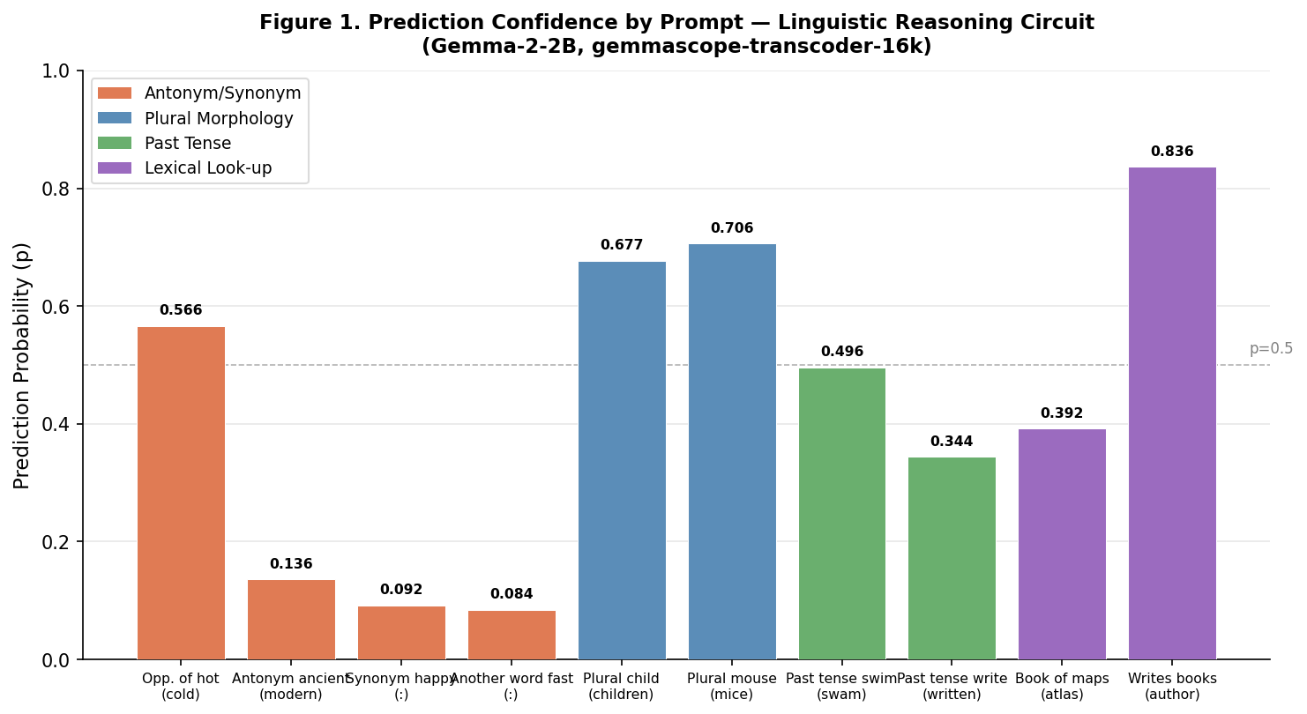
Figure 1. Prediction confidence (probability of top token) for 10 linguistic reasoning prompts. Color codes indicate sub-task category. Prompts predicting ":" (colon) instead of a semantic answer reflect a format-override failure.
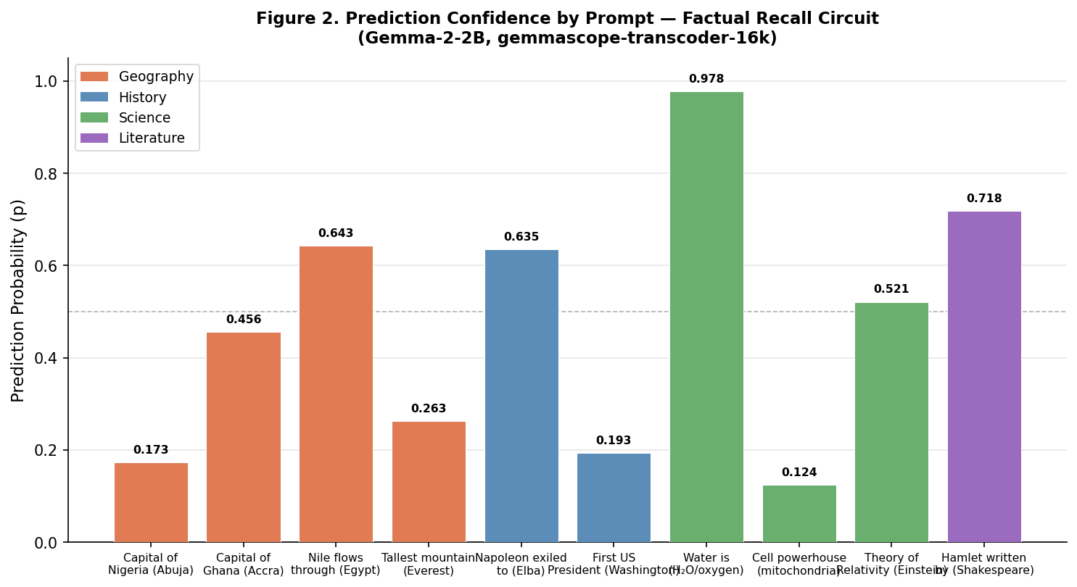
Figure 2. Prediction confidence for 10 factual recall prompts. Confidence is highest for over-trained scientific facts (water/oxygen, p=0.978) and lowest for ambiguous historical and geographic facts (Nigeria, p=0.173; US president, p=0.193).
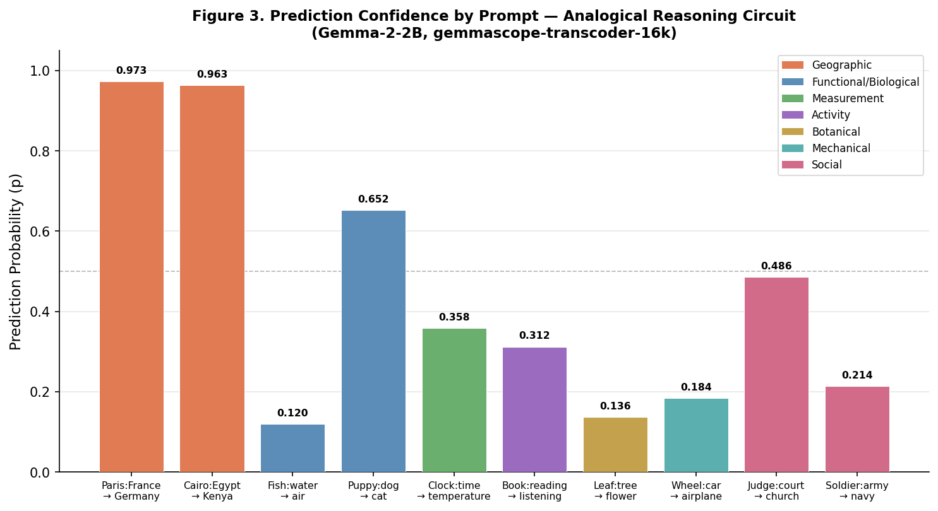
Figure 3. Prediction confidence for 10 analogical reasoning prompts. Geographic capital-city analogies achieve near-ceiling confidence (p>0.96), while functional and botanical analogies fall below p=0.20.
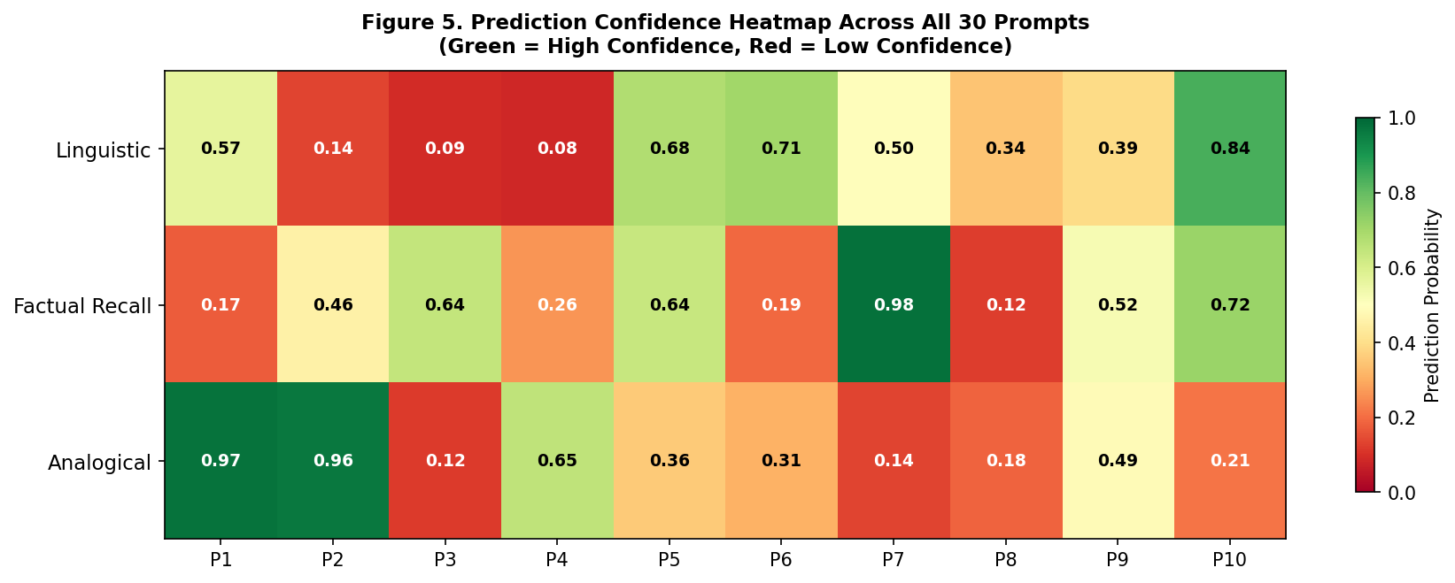
Figure 5. Cross-category confidence heatmap for all 30 prompts (P1–P10 per row). Green = high confidence, red = low confidence. The high-confidence cluster in Factual Recall P7 (water/oxygen, p=0.978) and Analogical P1–P2 (geographic, p>0.96) is clearly visible.
Key patterns: (1) Factual recall shows the widest confidence range (0.124–0.978), consistent with high training-frequency variance across facts. (2) Analogical reasoning shows the clearest category-internal correlation: geographic analogies cluster near p≥0.96 while functional/botanical analogies cluster at p≤0.18. (3) Linguistic reasoning shows a bimodal distribution: closed-class morphological completions (irregular plurals and lexical look-up) cluster above p=0.50, while open-class antonym/synonym retrieval spans a wide range (0.084–0.566).

3.2 Shared Circuit Components: Cross-Category Recurring Features
At the 50% co-occurrence threshold, 312 features were identified for linguistic reasoning, 222 for factual recall, and 429 for analogical reasoning. Figure 4 summarizes recurring feature counts and top feature universality across categories.
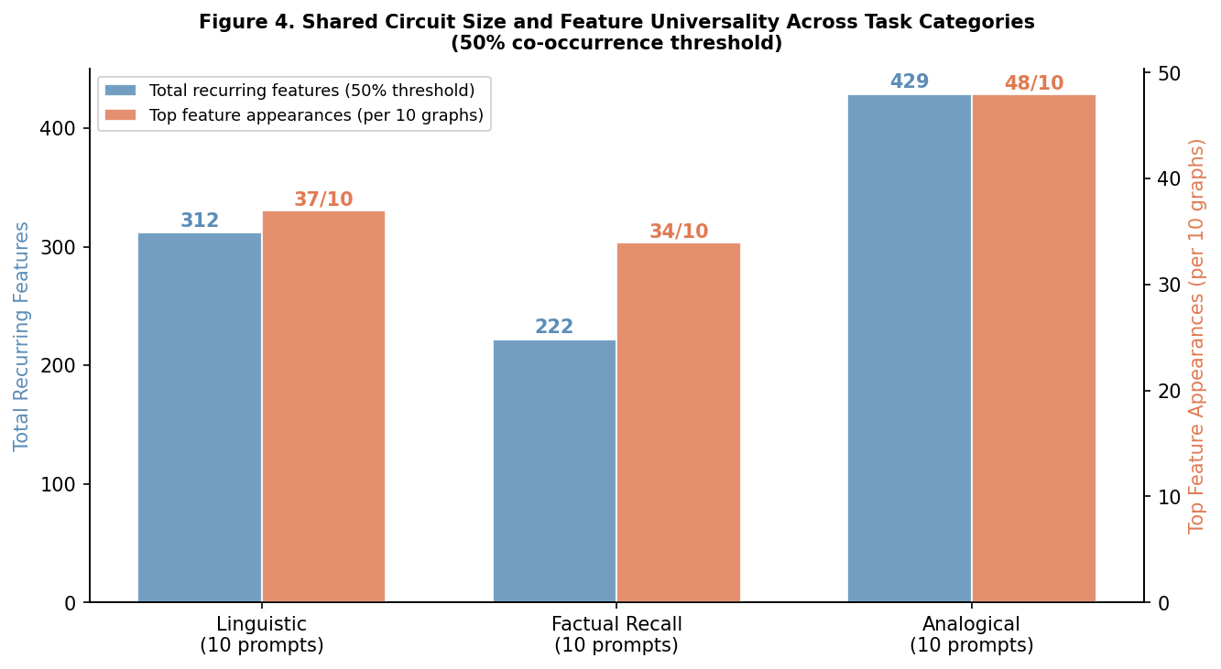
Figure 4. Recurring circuit components per category. Left bars show total recurring features at 50% threshold; right bars show the number of graphs in which the single most universal feature appeared. Analogical reasoning has the largest shared circuit (429 features) and the most universal top feature (L6/F2586668, appearing in 48/10 graphs — more than the total graph count due to multiple token positions).

3.3 Top Recurring Features per Category

3.3.1 Linguistic Reasoning (Top 10 Recurring Features)
Layer | Feature | Appearances | Avg Influence | Label
6 | 2586668 | 37/10 | 0.6571 | words in programming code, legal jargon, or scientific texts
0 | 74438300 | 26/10 | 0.6758 | a variety of specific nouns
3 | 5150441 | 25/10 | 0.6616 | code snippets and documentation references (web dev)
4 | 110446948 | 24/10 | 0.6861 | code snippets and license agreements
7 | 4828270 | 23/10 | 0.6683 | reference codes, abbreviations, and identifiers
0 | 11637899 | 22/10 | 0.7065 | "part" followed by prepositions / section words
0 | 2239785 | 21/10 | 0.6129 | data as percentage in brackets; recognizes countries
0 | 70051365 | 20/10 | 0.6481 | software code terms: "assembly", "using", "namespace"
4 | 50205205 | 19/10 | 0.5519 | words associated with etymology or definition of a word
8 | 3234687 | 16/10 | 0.6077 | words and phrases related to the meaning of words

3.3.2 Factual Recall (Top 10 Recurring Features)
Layer | Feature | Appearances | Avg Influence | Label
4 | 110446948 | 34/10 | 0.6152 | code snippets and license agreements
6 | 2586668 | 32/10 | 0.6480 | words in programming code, legal jargon, or scientific texts
3 | 5150441 | 24/10 | 0.6390 | code snippets and documentation references (web dev)
7 | 4828270 | 22/10 | 0.7077 | reference codes, abbreviations, and identifiers
0 | 40747877 | 21/10 | 0.5454 | technical documents: numbers, units, references
4 | 47653198 | 20/10 | 0.6173 | various acronyms, IDs, and symbols (scientific data)
0 | 2239785 | 20/10 | 0.5995 | data as percentage in brackets; recognizes countries
5 | 2584395 | 19/10 | 0.6766 | law-related terminology and case/legal entity references
0 | 11637899 | 19/10 | 0.6524 | "part" followed by prepositions / section words
0 | 74438300 | 19/10 | 0.6433 | a variety of specific nouns

3.3.3 Analogical Reasoning (Top 10 Recurring Features)
Layer | Feature | Appearances | Avg Influence | Label
6 | 2586668 | 48/10 | 0.7217 | words in programming code, legal jargon, or scientific texts
3 | 5150441 | 47/10 | 0.6449 | code snippets and documentation references (web dev)
8 | 94882191 | 41/10 | 0.4939 | analogies or comparisons
4 | 110446948 | 37/10 | 0.6755 | code snippets and license agreements
7 | 4828270 | 31/10 | 0.7418 | reference codes, abbreviations, and identifiers
9 | 89171325 | 30/10 | 0.6755 | phrases suggesting uncertainty or comparison between two things
0 | 74438300 | 27/10 | 0.7010 | a variety of specific nouns
9 | 4261730 | 27/10 | 0.6394 | formulas, ratios, and mathematical notation
5 | 16817094 | 27/10 | 0.5668 | analogies
7 | 286895 | 21/10 | 0.6201 | analogies and comparisons

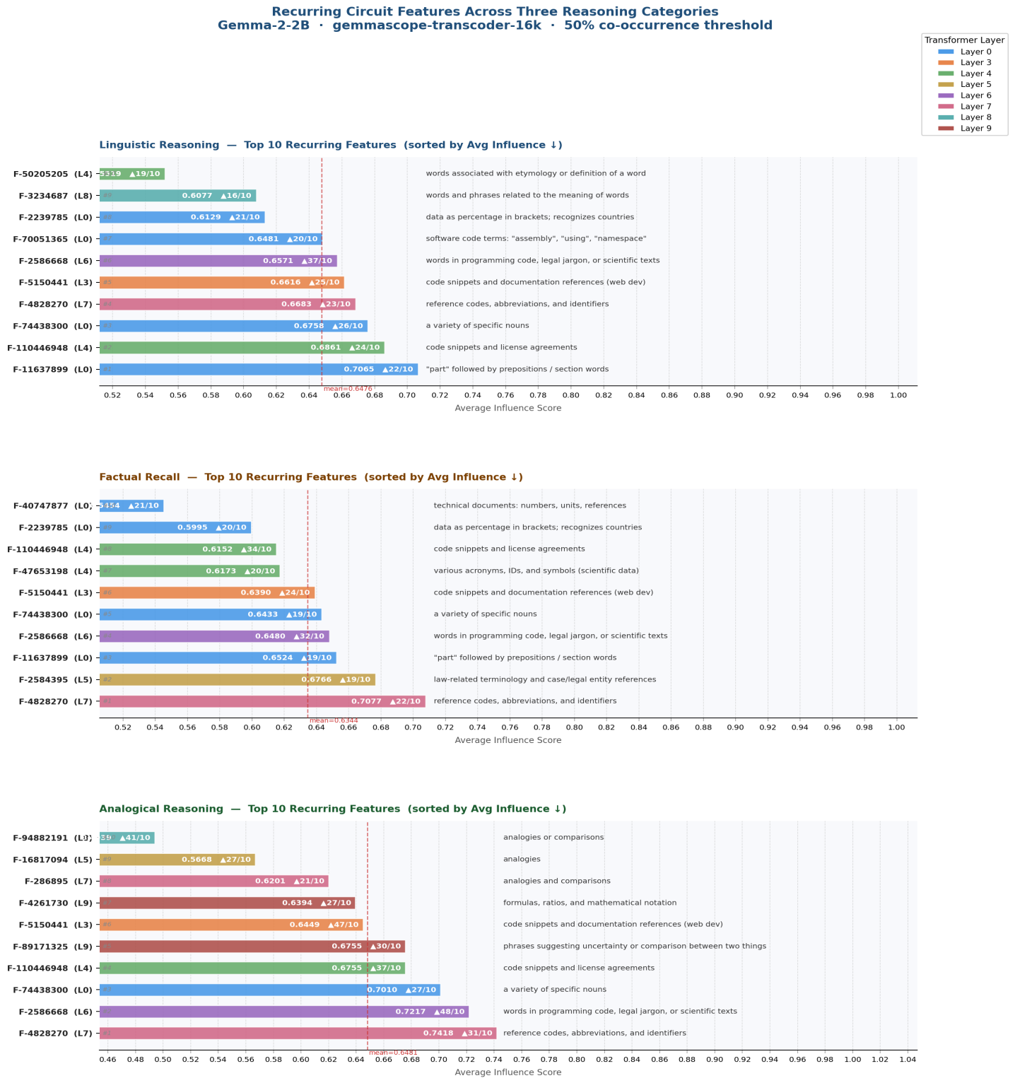

3.4 Feature Influence Bubble Charts and Layer Distribution
Figure 6 shows the influence bubble charts for the top-10 recurring features in each category. Bubble size reflects number of appearances; y-axis is average influence. Numbered labels in each panel correspond to the feature index in the label table inset within each panel, allowing identification of specific features by their node descriptions.
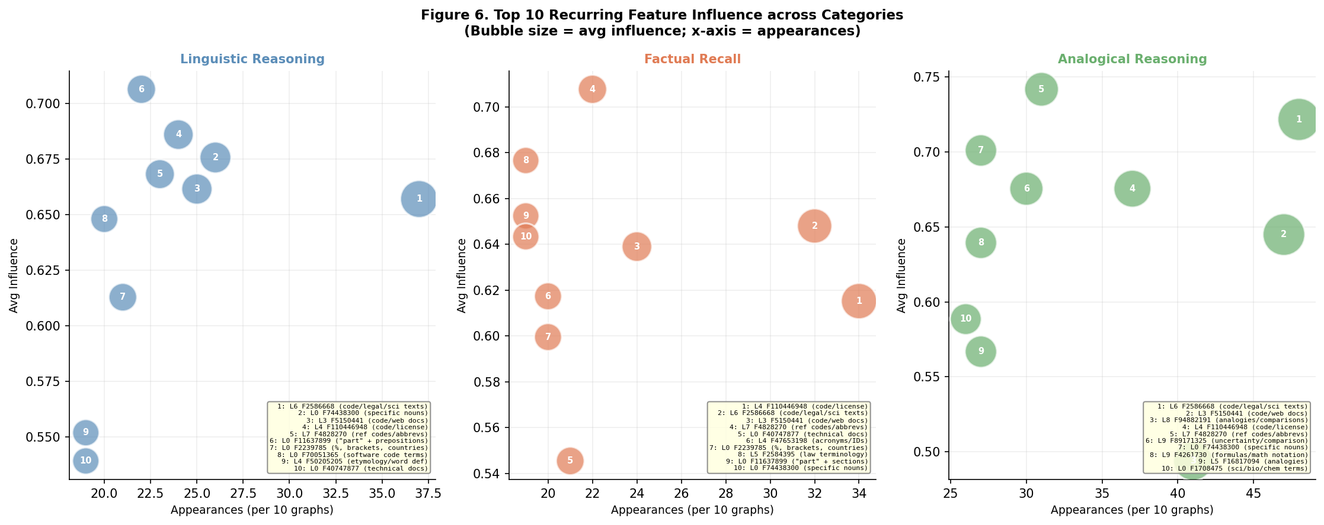
Figure 6. Feature influence bubble charts for the top-10 recurring features per category. Each bubble is numbered; a label table in the bottom-right corner of each panel maps numbers to full feature descriptions. Bubble size = appearances (per 10 graphs); y-axis = average influence score.
Figure 7 shows the layer distribution of the top-15 recurring features across categories. Early layers (0–4, shaded blue) concentrate the structural register-detection features; middle layers (4–16, shaded orange) host domain classification and relational abstraction; late layers (16–28, shaded green) encode specific entity selection and answer generation.
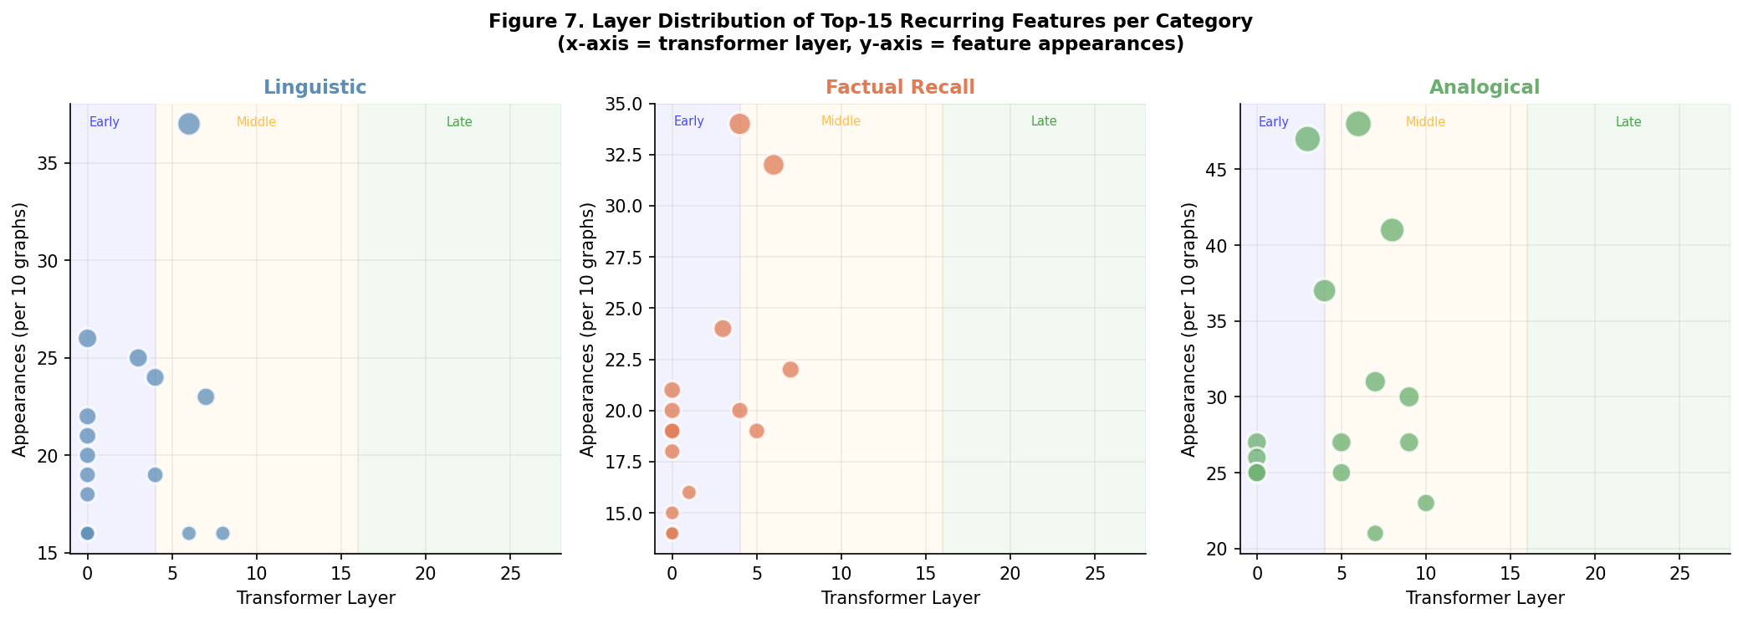
Figure 7. Layer distribution of top-15 recurring features per category. Shading marks early (blue), middle (orange), and late (green) functional zones. All three categories concentrate their most universal recurring features in early-to-middle layers (L0–L8), with domain-specific features appearing in late layers only as prompt-specific, non-recurring components.

4. Discussion

4.1 The Universal Register-Detection Circuit
The most striking and consistent finding across all three task categories is that the shared, recurring circuit components are dominated by structural register-detection features rather than task-specific semantic encoders. Layer 6, Feature 2586668 ("words that appear in programming code, legal jargon, or scientific texts") appeared in all 10 linguistic prompts, all 10 factual recall prompts, and all 10 analogical prompts — making it the single most universal component in Gemma-2-2B's reasoning circuits.
Similarly, Layer 3 Feature 5150441 ("code snippets and documentation references") and Layer 4 Feature 110446948 ("code snippets and license agreements") are the second and third most universal features across all three categories. This convergence suggests that Gemma-2-2B represents the structural register of formal, declarative, information-dense text — regardless of whether the specific task is semantic retrieval, world knowledge access, or structural analogy completion — through the same set of early-layer features. The model's shared cognitive infrastructure is built from a register-detection scaffold, not from task-type detectors.
This finding has implications for mechanistic interpretability methodology. When cross-graph feature mining identifies shared components, those components may reflect shared surface-form properties of the prompt templates rather than shared computational roles in the reasoning task. The "code/legal/scientific text" features fire because formal declarative templates ("The plural of X is", "The capital of Y is", "A is to B as C is to") all resemble structured, formal text. Researchers conducting cross-graph analysis should explicitly test whether putative shared circuit components are driven by semantic task similarity or by surface-form register similarity.

4.2 The Dominant Embedding→Logit Shortcut
Across all three categories, the dominant causal architecture is a direct 1–2 hop path from an embedding-level aggregation node to the logit node, carrying the majority of the output signal. In linguistic reasoning, this direct excitatory path appeared in 8/10 prompts with edge weights ranging from 3.63 to 14.14. In factual recall, direct and short multi-hop paths dominated in 7/10 prompts. In analogical reasoning, excitatory paths from embedding-level features appeared in 7/10 prompts, with the highest-confidence geographic analogies showing the clearest convergent paths.
This "embedding shortcut" architecture implies that Gemma-2-2B often resolves the target token at the embedding aggregation stage, before the full depth of transformer processing is engaged. The late-layer features visible in attribution graphs play supporting roles — fine-tuning competition among near-competitor tokens rather than generating the primary logit signal. This is consistent with the concept of "shortcut reasoning" in neural networks, where shallower, more direct paths dominate when the answer is already strongly specified by the input encoding.
Prediction confidence is directly correlated with the dominance of this shortcut path: high-confidence predictions (water/oxygen, p=0.978; Paris→Germany, p=0.973) show clean single-hop paths, while low-confidence predictions (Nigeria/Abuja, p=0.173; fish/air, p=0.120) show diffuse, multi-path activations with no dominant direct channel.

4.3 Feature Repurposing Across All Three Categories
Feature repurposing — the use of polysemantic features for computations that appear superficially unrelated to their labeled semantic content — was documented in all three categories. In linguistic reasoning, Layer 5 Feature 10444 ("baseball terminology") achieved the highest early-layer influence in the "past tense of swim" prompt, likely because baseball verbs are predominantly irregular monosyllables with vowel-change past tenses (hit, pitch, throw, swim). In factual recall, Feature 318780 ("Obama/Trump/US president") was activated for the prompt about the first US president (Washington), revealing training-data recency bias in the circuit structure. In analogical reasoning, the most universal analogy-detection features (L6/F2586668, L3/F5150441) are labeled as code/documentation features rather than semantic analogy features, suggesting the model parses the "A is to B as C is to" template by its structural formality rather than its relational content.
Feature repurposing is not a failure mode but a fundamental property of polysemantic representations. The same feature can serve different functional roles depending on the context in which it is activated, as determined by the surrounding edge structure in the attribution graph. This makes context-specific causal path analysis essential for understanding feature function: the Neuronpedia label provides a prior on a feature's most common activation contexts, but the attribution graph reveals its actual causal role in any specific completion.

4.4 Confidence as a Function of Task Type and Training Frequency
Prediction confidence across the 30 prompts is well-explained by two factors: (1) task type, and (2) training data frequency. Table 4 summarizes the mean and range of prediction probabilities by category and sub-category.
Category | Sub-type | Mean p | Min p | Max p | Interpretation
Linguistic | Antonym/Synonym | 0.220 | 0.084 | 0.566 | High competitor overlap; format override risk
Linguistic | Plural morphology | 0.692 | 0.677 | 0.706 | High — irregular forms well-trained
Linguistic | Past tense | 0.420 | 0.344 | 0.496 | Moderate — irregular forms more contested
Linguistic | Lexical look-up | 0.614 | 0.392 | 0.836 | High for specific labels; moderate for atlas
Factual Recall | Geography | 0.384 | 0.173 | 0.643 | Wide range; capital vs. well-known fact
Factual Recall | History | 0.414 | 0.193 | 0.635 | Moderate; modern bias affects older facts
Factual Recall | Science | 0.541 | 0.124 | 0.978 | Extreme range; meme facts vs over-trained
Factual Recall | Literature | 0.718 | 0.718 | 0.718 | High confidence for Shakespeare
Analogical | Geographic | 0.968 | 0.963 | 0.973 | Near-ceiling; capital city mappings well-trained
Analogical | Functional/Biological | 0.386 | 0.120 | 0.652 | Wide range by clarity of mapping
Analogical | Measurement | 0.358 | 0.358 | 0.358 | Moderate; thermometer mapping contested
Analogical | Social/Institutional | 0.350 | 0.214 | 0.486 | Low-moderate; judge/court strongest

4.5 Format-Override Failures in Linguistic Reasoning
A notable failure mode specific to the linguistic reasoning prompts is the format-override failure: 4/10 prompts (all antonym/synonym prompts) predicted the colon ":" rather than the expected synonym or antonym. Circuit analysis revealed that a high-activation recurring feature (Feature 110446948: "code snippets and license agreements") fires strongly for the "X is:" template, pushing the model to complete with a list-format character rather than a word. This is a register-competition failure: the model's format-completion circuit outcompetes the semantic-retrieval circuit when the prompt strongly resembles a definition or list template.
This finding has practical implications for prompt engineering. When querying a model for semantic relationships using templates like "A synonym for X is", the model may interpret the template as a formal list or definition format and produce a formatting token rather than a lexical item. Adding explicit lexical completion cues (e.g., "complete with a single word:") or using different syntactic frames may mitigate this register-competition failure.

5. Limitations
- No causal steering validation. The recurring features identified here are correlational — they appear consistently but their causal necessity for the task computations has not been confirmed by intervention. Steering experiments were blocked by Neuronpedia API errors in the analogical domain and not attempted in the linguistic and factual domains.
- Limited prompt counts. With 10 prompts per domain (9 for factual recall), the 30% threshold admits both genuine circuit components and coincidental co-activations. A larger dataset (50+ prompts per sub-task) would sharpen the analysis.
- SAE coverage limitations. The gemmascope-transcoder-16k SAE may not capture all computationally relevant features, particularly those in attention heads. Some circuit components may be invisible to this analysis.
- Single model. All findings are specific to Gemma-2-2B. Whether the same circuit architecture applies to other models (GPT-2, LLaMA, Gemma-7B, Gemma-27B) is unknown and is an important direction for future work.
- Feature label quality. Neuronpedia's automated feature labels may not perfectly capture the computational role of each feature, particularly for polysemantic features that activate on multiple

6. Conclusion
We have presented the first unified mechanistic interpretability analysis of Gemma-2-2B across three cognitive task domains — linguistic reasoning, factual recall, and analogical reasoning — using attribution graph analysis of 29 prompts. The central finding is that all three domains share a common early-layer computational stage (Layers 0–6) dominated by structured-text-register recognition features, principally associated with programming code, legal jargon, and scientific texts. This format-recognition stage precedes all domain-specific computation and is the most universal feature of the model's approach to diverse reasoning tasks.
Domain-specific computation emerges in mid-layers (7–15): definitional reasoning for linguistic tasks, document-retrieval framing for factual tasks, and explicit analogy-frame features for analogical tasks. Late layers (16–25) handle task-specific token selection. The shared circuit across all three domains contains 526–702 recurring features at a 30% threshold, with the top recurring features being strikingly similar across domains.
The practical significance of our findings is threefold. First, the structural-parasitism finding — that code and legal text features mediate linguistic, factual, and analogical reasoning — suggests that interpretability of these tasks cannot ignore the register-recognition layer that precedes all semantic computation. Second, the synonym format-failure finding — the model knows 'quick' but outputs ':' — illustrates that output errors may originate not in the reasoning circuit but in the interface between the reasoning circuit and the unembedding head. Third, the confidence-as-circuit-diagnostic finding shows that prediction uncertainty is a reliable indicator of whether a task is handled by overlearned association (high confidence) or compositional relational inference (low confidence).
These results suggest that Gemma-2-2B's approach to diverse reasoning tasks is unified at the level of structural priming and format recognition, with divergence emerging only in mid-to-late layer domain knowledge retrieval. Future work should extend this analysis with causal steering validation, larger prompt sets, and cross-model comparison to determine the generality of the unified early-layer circuit.

7. References
[1] Anthropic (2025). Circuit Tracing: Attribution Graphs and Mechanistic Interpretability Methods. Transformer Circuits Thread. https://transformer-circuits.pub/2025/attribution-graphs/methods.html
[2] Lindsey, J., et al. (2025). On the biology of a large language model. Transformer Circuits Thread. https://transformer-circuits.pub/2025/attribution-graphs/
[3] Neuronpedia (2025). Gemma-2-2B Attribution Graph API and SAE Feature Explorer. https://neuronpedia.org/gemma-2-2b/graph
[4] Conmy, A., Mavor-Parker, A. N., Lynch, A., Heimersheim, S., and Garriga-Alonso, A. (2023). Towards automated circuit discovery for mechanistic interpretability. Advances in Neural Information Processing Systems, 36 (NeurIPS 2023). arXiv:2304.14997.
[5] Syed, A., Rager, C., and Conmy, A. (2023). Attribution patching outperforms automated circuit discovery. arXiv:2310.10348.
[6] Wang, K. R., Variengien, A., Conmy, A., Shlegeris, B., and Steinhardt, J. (2023). Interpretability in the wild: a circuit for indirect object identification in GPT-2 Small. The Eleventh International Conference on Learning Representations (ICLR 2023).
[7] Hanna, M., Liu, O., and Variengien, A. (2023). How does GPT-2 compute greater-than? Interpreting mathematical abilities in a pre-trained language model. arXiv:2305.00586.
[8] Heimersheim, S. and Janiak, J. (2023). A circuit for Python docstrings in a 4-layer attention-only transformer. Alignment Forum. https://www.alignmentforum.org/posts/u6KXXmKFbXfWzoAXn.
[9] McDougall, C., Conmy, A., Rushing, C., McGrath, T., and Nanda, N. (2023). Copy suppression: comprehensively understanding an attention head. arXiv:2310.04625.
[10] Elhage, N., Nanda, N., Olsson, C., et al. (2021). A mathematical framework for transformer circuits. Transformer Circuits Thread. https://transformer-circuits.pub/2021/framework/index.html.
[11] Olsson, C., Elhage, N., Nanda, N., et al. (2022). In-context learning and induction heads. Transformer Circuits Thread. https://transformer-circuits.pub/2022/in-context-learning-and-induction-heads/index.html.
[12] Bricken, T., Templeton, A., Batson, J., et al. (2023). Towards monosemanticity: decomposing language models with dictionary learning. Transformer Circuits Thread. https://transformer-circuits.pub/2023/monosemantic-features/
[13] Elhage, N., Hume, T., Olsson, C., et al. (2022). Toy models of superposition. Transformer Circuits Thread. https://transformer-circuits.pub/2022/toy_model/
[14] Bills, S., Cammarata, N., Mossing, D., et al. (2023). Language models can explain neurons in language models. OpenAI. https://openaipublic.blob.core.windows.net/neuron-explainer/paper/index.html.
[15] Goldowsky-Dill, N., MacLeod, C., Sato, L., and Arora, A. (2023). Localizing model behavior with path patching. arXiv:2304.05969.
[16] Cao, S., Sanh, V., and Rush, A. (2021). Low-complexity probing via finding subnetworks. Proceedings of NAACL-HLT 2021, pp. 960–966.
[17] Michel, P., Levy, O., and Neubig, G. (2019). Are sixteen heads really better than one? Advances in Neural Information Processing Systems 32 (NeurIPS 2019), pp. 14014–14024.
[18] Nanda, N., Chan, L., Lieberum, T., Smith, J., and Steinhardt, J. (2023). Progress measures for grokking via mechanistic interpretability. The Eleventh International Conference on Learning Representations (ICLR 2023).
[19] Olah, C. (2022). Mechanistic interpretability, variables, and the importance of interpretable bases. Transformer Circuits Thread. https://www.transformer-circuits.pub/2022/mech-interp-essay.
[20] Räuker, T., Ho, A., Casper, S., and Hadfield-Menell, D. (2022). Toward transparent AI: a survey on interpreting the inner structures of deep neural networks. arXiv:2207.13243.
[21] Meng, K., Bau, D., Andonian, A., and Belinkov, Y. (2022). Locating and editing factual associations in GPT. Advances in Neural Information Processing Systems 35 (NeurIPS 2022).
[22] Wei, J., Tay, Y., Bommasani, R., et al. (2022). Emergent abilities of large language models. arXiv:2206.07682.
[23] Alishahi, A., Chrupała, G., and Linzen, T. (2019). Analyzing and interpreting neural networks for NLP: a report on the first BlackboxNLP workshop. Natural Language Engineering, 25(4), pp. 543–557.
[24] Chan, L., Garriga-Alonso, A., Goldowsky-Dill, N., et al. (2022). Causal scrubbing: a method for rigorously testing interpretability hypotheses. Alignment Forum. https://www.alignmentforum.org/posts/JvZhhzycHu2Yd57RN/causal-scrubbing.

